Conversation 101

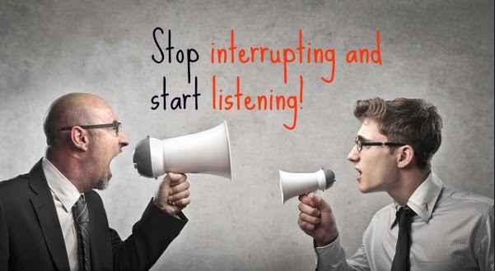

#1
Question: How do you react in the following situations:
(a) You are talking with a friend and your phone rings.
(b) You are talking with a friend and you receive a text message.
(c) You are in the middle of a phone call with your friend. Someone calls you at the same time...

#2
Question: How do you feel when someone interrupts while talking to you and answers the phone, texts back, apologizes and accepts another phone call in the middle of your conversation?

#3
Pirkei Avos 5:9
There are seven characteristics of an uncultivated person, and seven of a wise person: (1) A wise person does not speak in front of one who is wiser or older than he, (2) he does not interrupt his friend, (3) he is not hasty to answer, (4) he asks to the point and answers accurately, (5) he discusses the first point first and the last point last, (6) concerning that which he has not heard he says, “I have not heard,” (7) and he acknowledges the truth. The uncultivated person has the opposite traits.

Relevance, Rabbi Don Roth
The traits listed in the Mishnah follow the chronological order of the way people speak: how to behave before the conversation begins, how to act while the other person is talking, and what to do once he has finished.

(a)
Visions of the Fathers, Rabbi Abraham J. Twerski M.D.
The seven traits that the Mishnah lists of an uncultivated person can all be seen as manifestations of the defensiveness of a person with a poor self-image.

Question: Do you see how the opposite traits of a wise person could be manifestations of a low self-esteem?

(b)
Question: Are these characteristics just an indication if a person is wise or the opposite, or can they cause a person to become wise or opposite?

#4
Pirkei Avos 5:9
(1) A wise person does not speak in front of one who is wiser or older than he...
Relevance, Rabbi Don Roth
This does not mean that he remains totally quiet without saying a word. The intent, rather, is that he is more concerned with listening to what others have to say than with telling them what he has to say.

Questions:
What if the one who is older is not really wiser- you are 100 times wiser than him?
What if he is half a year older than you - would you treat him as an older person?

#5
Pirkei Avos 5:9
(2) he does not interrupt his friend…
Nachalas Avos
The attribute of not interrupting another person also includes pausing for a moment after the person finishes speaking.

Question: According to this explanation, even if you let your friend finish his thought and reply immediately you are interrupting him. Is that not a bit too much?

#6
(3) he is not hasty to answer…
Rabeinu Yona
It means more than merely waiting a certain amount of time before responding. It requires thinking about what the other person has said, and not responding until you have taken the time to reflect on his words.

Questions:
Do you expect an immediate response the moment you finish posing your question or presenting your argument?
Would you consider it strange should the listener fall silent for a few moments to contemplate?

#7
Question: What’s your takeaway from today’s discussion?

